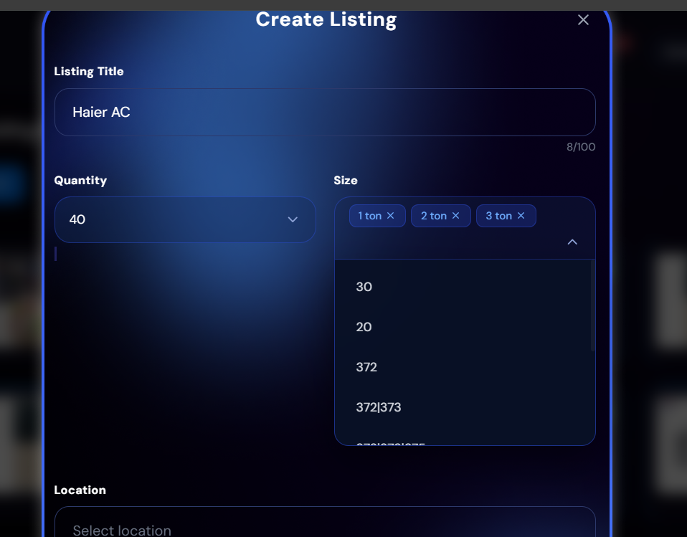
Dropdown issue

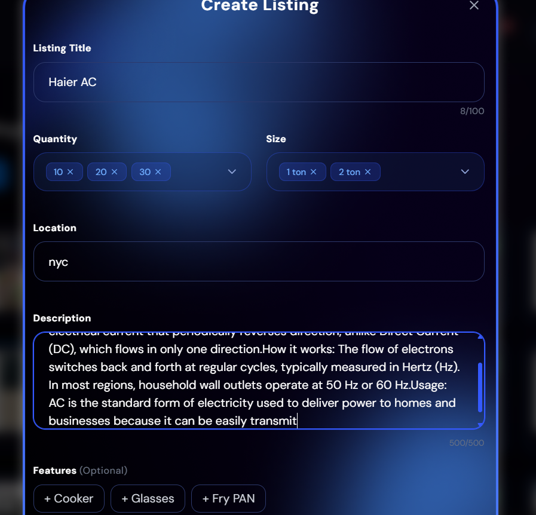

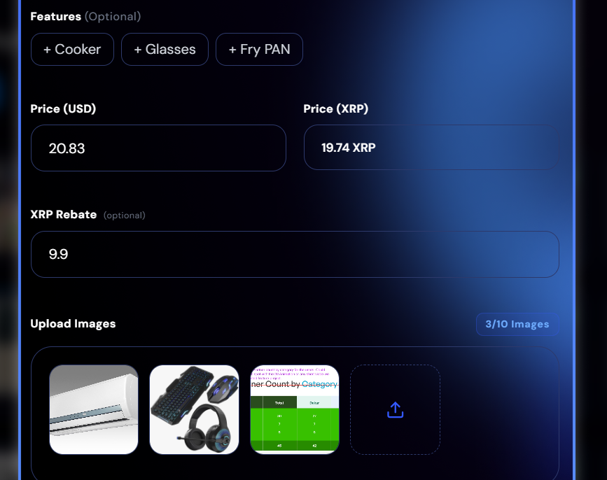
Listing not created

Admin closed the chrome but push notifications still appears
Listing not creating on points values and price
In Chat, When delete for everyone any pic with written text, it just deleted the text not the file / pic
Pic not fully open on buyer

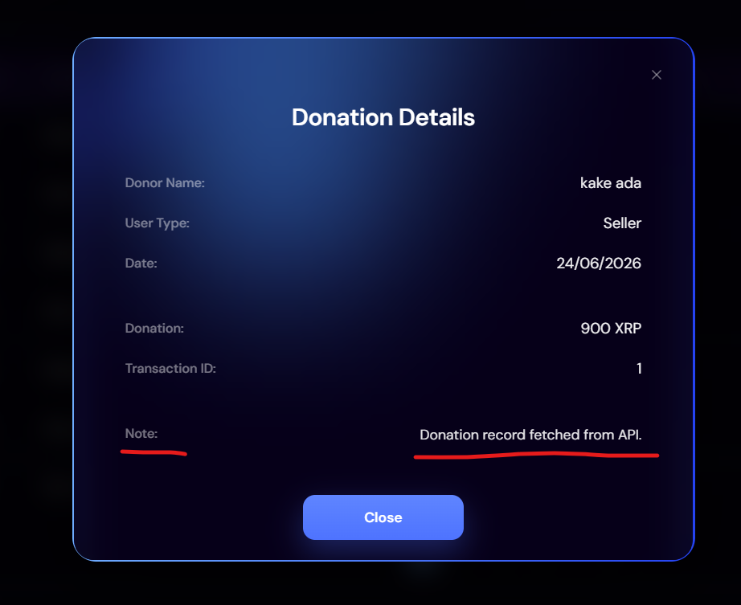
When seller donates the amount without any note, admin still shows note

